**Guy’s and St Thomas’ Personalised Treatment Pathway**

**& Patient Journal Project**

**Biweekly Status Report**

26th March 2015

**Version History**

|  |  |  |  |
| --- | --- | --- | --- |
| Author | Version | Date | Comment |
| Henry Scott-Green | 0.1 | 26th March | Draft |
| Henry Scott-Green | 1.0 | 26th March | Submitted for Review |

**High Level Status: Green­­**

**Breakdown**

* Further development progress has been made.
* Review meeting completed on March 17th with good progress agreed upon.
* Final intensive development session arranged for the weekend of March 28th.
* The app content data set has been provided to Sarah for review anda completed set is pending, to be received by April 17th.
* Publication under consideration, with research in progress.
* Proposal for Pathways 2.0 discussed at length during review meeting on March 17th.

**Risk Management**

**Outstanding Risks:**

1. All treatment, symptom, dietary and miscellaneous information sheets must be provided to the development team for inclusion in the application.

**Mitigating Actions:**

1. Ownership of data is now with the clinical team. Action for the development team to send the current data set to the clinical team, data due by April 17th.

**Low Level Status**

**Team Task Tracker**

* Project development has continued.
* Bi-Weekly has been completed.
* UI improvements underway.
* Further development has been undertaken by the team.
* SCRUM Sprint session scheduled to complete final website and product development.
* Numerous gems installed and Slack integrations configured.
* Bug tracking update:

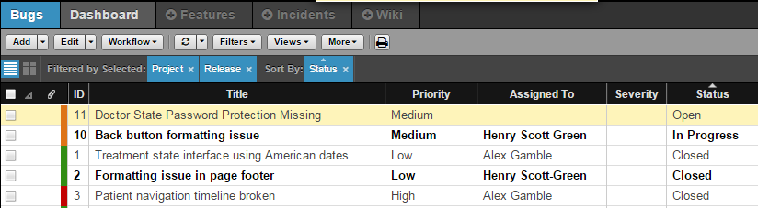

**Deliverable Progress and Development Team Task Assignment**

**Deliverable 1 - Website**

* Completed.

**Deliverable 2 - Application**

* First prototype completed (without the required skeleton of information)
* Development of the final version of the application is almost complete.
* Bug fixing underway

**Deliverable 3 – Final Website**

* Under construction