**Guy’s and St Thomas’ Personalised Treatment Pathway**

**& Patient Journal Project**

**Biweekly Status Report**

26th February 2015

**Version History**

|  |  |  |  |
| --- | --- | --- | --- |
| Author | Version | Date | Comment |
| Henry Scott-Green | 0.1 | 25th February | Draft |
| Henry Scott-Green | 1.0 | 25th February | Submitted for Review |

**High Level Status: Green­­**

**Breakdown**

* Very significant progress has been made in the development of the application. Pages and functionality are now entirely completed for:
  + Home
  + Patients hub
  + Doctors hub
  + Patient login
  + Treatment state assignment
  + Patient state update
  + Patient timeline
  + Team management
  + Treatment module addition
  + Treatment module modification
  + Patient treatment state viewer
  + Doctor treatment state viewer
* Significant user interface improvements have been implemented.
* Professional external issue tracking software has been implemented to monitor bugs before the final release. Access to this has been provided to the clinical team to raise issues with the development team, credentials are: [sarah.payne@gstt.nhs.uk](mailto:sarah.payne@gstt.nhs.uk) // Nutrition1
* All data provided has been sorted, categorised and loaded into the application.
* Further information that is not yet provided has been requested from the clinical team.
* Access to GSTT Azure was granted.
* The application has been successfully hosted on GSTT Azure.
* Final application was presented to the clinical team on 26th February and received very positive feedback. Priorities for the product moving forward are:
  + Modified data heading names
  + Confirmation of data assignment changes
  + Image hosting

**Risk Management**

**Outstanding Risks:**

1. All treatment, symptom, dietary and miscellaneous information sheets must be provided to the development team for inclusion in the application.

**Mitigating Actions:**

1. Ownership of data is now with the clinical team. Action for the development team to send the current data set to the clinical team.

**Low Level Status**

**Team Task Tracker**

* The development team have worked full time over the university reading week using sprint development methodology to progress on all areas of the project.
* Bug tracking software has been implemented to manage issues before launch:

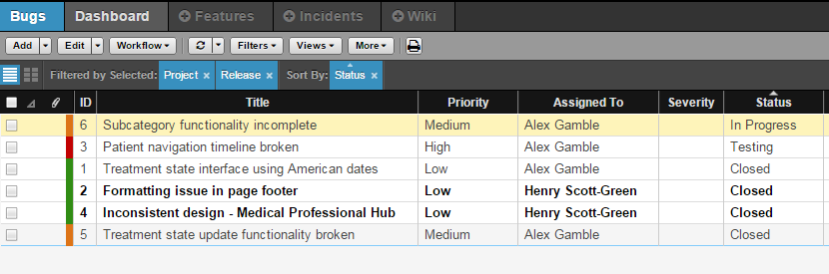

**Deliverable Progress and Development Team Task Assignment**

**Deliverable 1 - Website**

* Completed.

**Deliverable 2 - Application**

* First prototype completed (without the required skeleton of information)
* Development of the final version of the application is almost complete.