**Guy’s and St Thomas’ Personalised Treatment Pathway**

**& Patient Journal Project**

**Biweekly Status Report**

12th March 2015

**Version History**

|  |  |  |  |
| --- | --- | --- | --- |
| Author | Version | Date | Comment |
| Henry Scott-Green | 0.1 | 12th March | Draft |
| Henry Scott-Green | 1.0 | 12th March | Submitted for Review |

**High Level Status: Green­­**

**Breakdown**

* Further development progress has been made. Tasks completed:
  + Confirmation of treatment state update
  + All doctor functionality now access protected
  + Requested header name changes made
  + Random password generation added
  + New patient creation and modification
* The app content data set has been provided to Sarah for review.
* Code refactoring in progress.
* Additional product features and directions considered for a Pathways 2.0 proposal.
* Open ticket stack reduced from last week.

**Risk Management**

**Outstanding Risks:**

1. All treatment, symptom, dietary and miscellaneous information sheets must be provided to the development team for inclusion in the application.

**Mitigating Actions:**

1. Ownership of data is now with the clinical team. Action for the development team to send the current data set to the clinical team.

**Low Level Status**

**Team Task Tracker**

* Project development has continued.
* Bug tracking update:

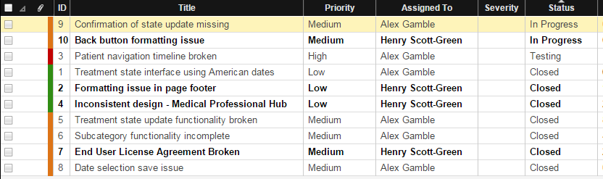

**Deliverable Progress and Development Team Task Assignment**

**Deliverable 1 - Website**

* Completed.

**Deliverable 2 - Application**

* First prototype completed (without the required skeleton of information)
* Development of the final version of the application is almost complete.